**How to store the value in variables and how many types of value stored in variable**

1. **JavaScript has 6 Datatypes (Primitive data types)**

* **String:** Represents textual data, enclosed within single ('') or double ("") quotes.
* **Number:** Represents numeric data, including integers and floating-point numbers.
* **Boolean:** Represents a logical value, either true or false.
* **Null:** Represents the intentional absence of any object value.
* **Undefined**: Indicates that a variable has been declared but has not been assigned a value.
* **Symbol (ES6):** Represents a unique and immutable value, often used as property keys in objects.

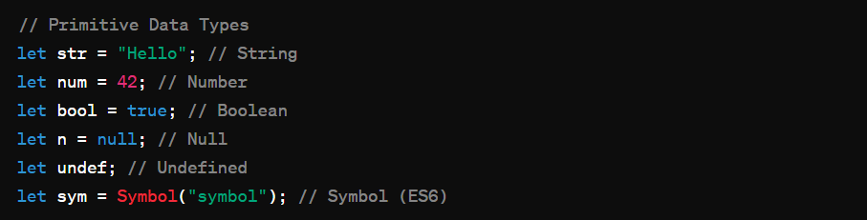

1. **The Object Datatype (Secondary data types)**

**Complex Data Types:**

* **Object:** A collection of key-value pairs, also referred to as properties and methods.
* **Array:** An ordered list of values, accessible by numeric indices.
* **Function:** A reusable block of code that performs a specific task.

